REGISTERING ON THE CIVIC ACCESS PORTAL

To register on the Civic Access Portal, click on the Guest icon in the top right corner, then click on Register from the dropdown.
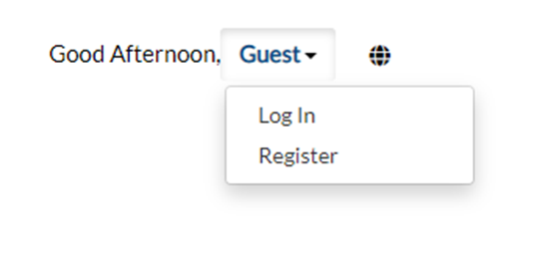

You will be prompted to acknowledge the new authentication service through the Portal, please click Continue.

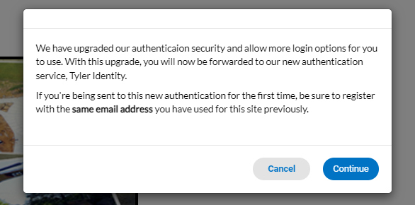

If you are a new user, please click Sign Up at the bottom of the sign in screen.
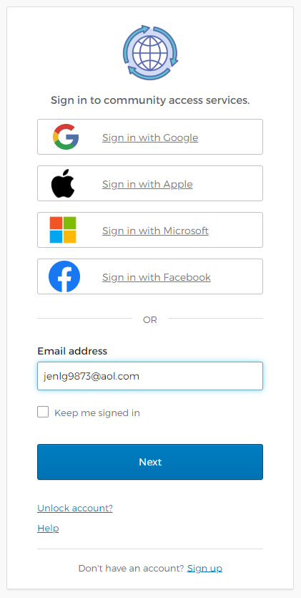

Enter your email address, first name, last name and create a password, then click Sign Up.

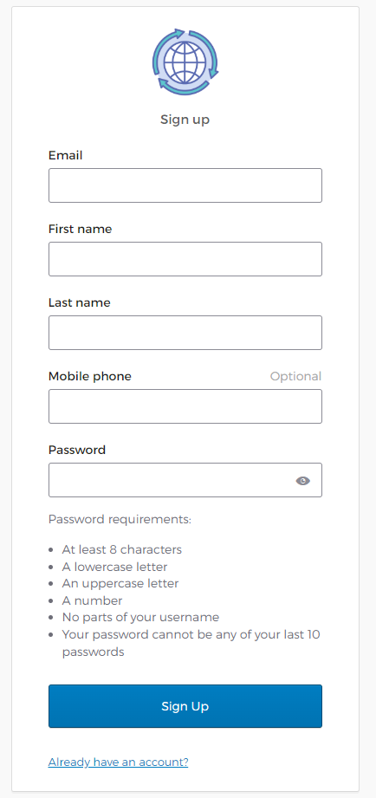

At this time, please check the email address you entered on the previous screen and enter the 6-digit verification code you will receive in an email from “Community Access”, then click Verify.

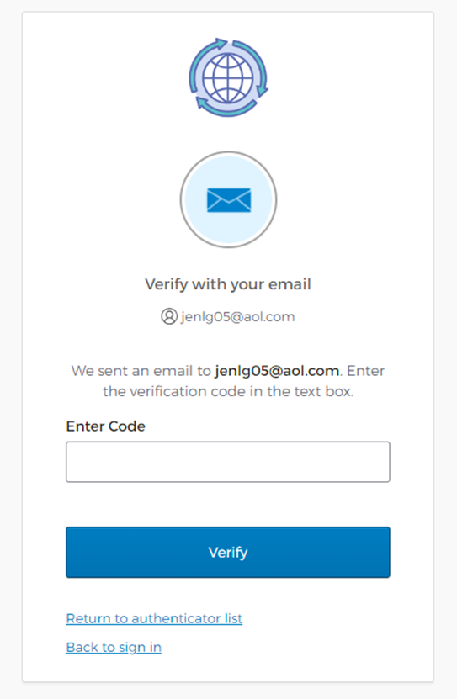

Your.email@domain.com

******

Step 1 of 3 of the Registration: Please click Continue to validate your user information.
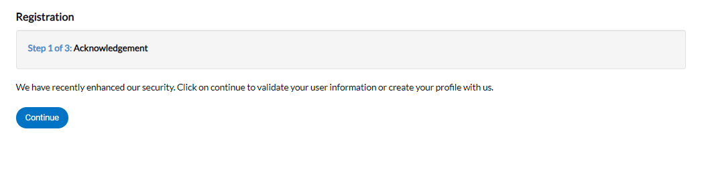

Step 2 of 3 of the Registration: Please confirm your information and choose your Contact Preference, then click Next.
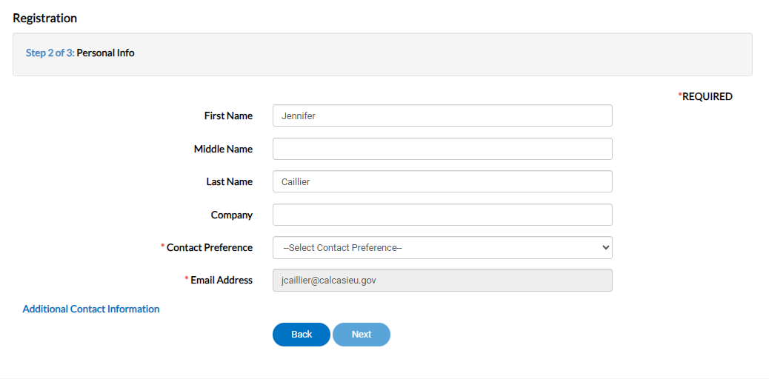

Step 3 of 3 of the Registration: Please enter your address information, then click Submit.
