LOGGING IN TO THE CIVIC ACCESS PORTAL

For returning users to Portal, please click on the Guest icon in the top right corner, then click on Log In from the dropdown.
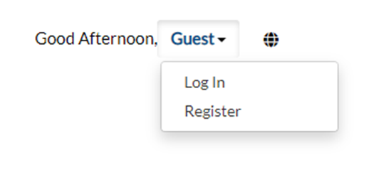

You will be prompted to acknowledge the new authentication service through the Portal, please click Continue.

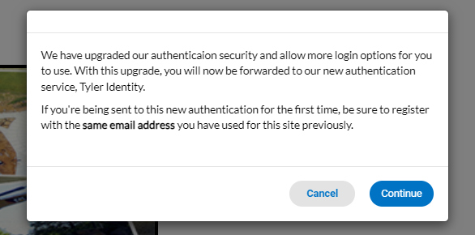

For the FIRST time using the new TID-C login PLEASE click SIGN UP at the bottom of this screen:

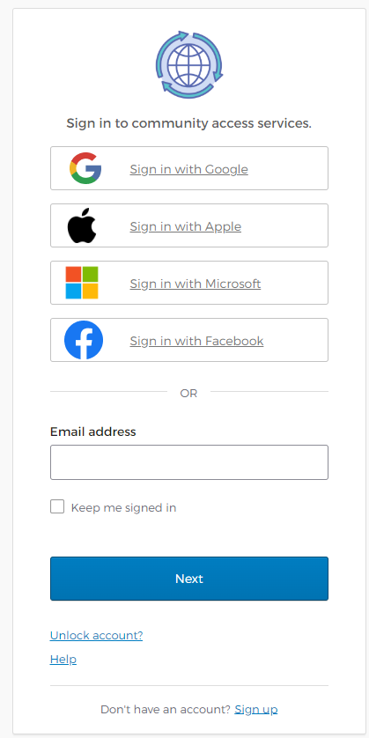
You will only have to do this ONE TIME to re-register your email account. After you have been registered this screen will require your email address, click Next then enter your password on the next screen.

On this screen fill out the listed fields and click Sign Up
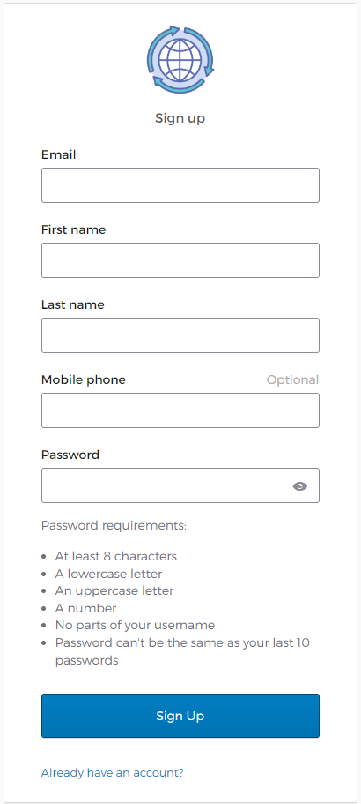

You will be sent an email from Community Access to complete the registration.

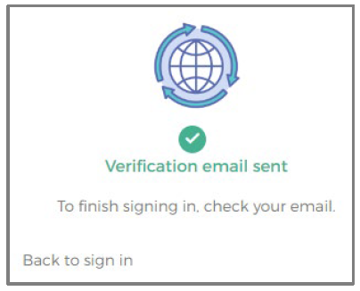

Once you open the email, please click Activate Account. After activation, you will be returned to the Civic Access home page.
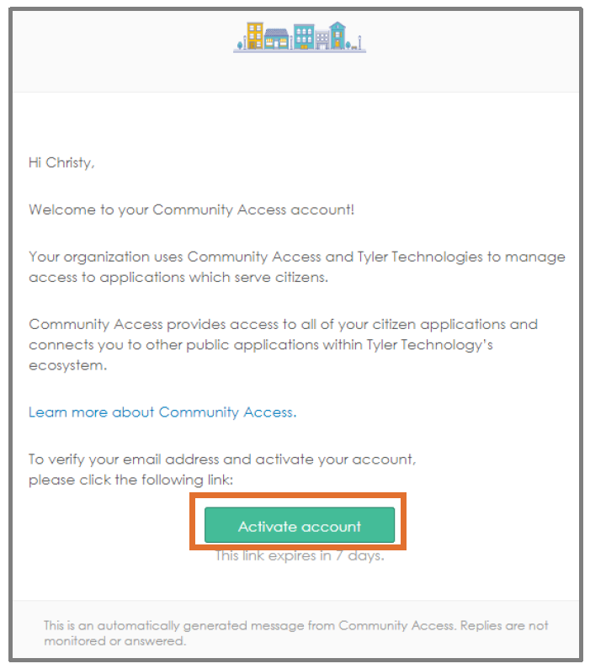

After you have activated your account, you will be taken to the Civic Access - CAP Home page.

